Title
Explainable AI in Computer Vision for Agricultural Disease and Pest Detection A Systematic Review of Methods, Trends, and Future Directions

Structure
Your Observation is Correct — and It's a Major Finding
You have identified one of the most significant gaps in this literature. All 30 papers used XAI methods (GradCAM, LIME, SHAP, etc.) purely as visual demonstration tools — showing heatmaps or saliency maps to make the model look interpretable — but none quantitatively measured whether the explanations themselves are actually good. This is a publishable critical finding on its own. Here is what they measured vs. what they ignored:
What ALL 30 papers measured | What NONE of the 30 papers measured
Accuracy, F1, Precision, Recall, AUC | Faithfulness / Fidelity of explanations
Confusion matrix | Pointing game / localization accuracy
Training/inference time | Insertion & Deletion scores
Model comparison (transfer learning baselines) | Inter-rater agreement on explanation quality
 | AOPC (Area Over Perturbation Curve)
 | Stability / consistency of explanations across runs
This gap directly strengthens your §8 (Limitations) and §9 (Future Directions), and elevates the value of your review.

Final Systematic Review Article Structure

1. Abstract
- Background: rapid adoption of XAI in agricultural computer vision; lack of evaluation rigor
- Objectives: systematically map XAI methods, architectures, crops, tasks, and evaluation practices
- Methodology: PRISMA-guided search on Scopus (search string + filters → 67 screened → 30 included)
- Key findings:
  - GradCAM dominates; LIME and SHAP are secondary
  - Zero papers quantitatively evaluated XAI explanation quality
  - Disease detection is the dominant task (~60% of papers)
- Conclusions: field is methodologically immature in XAI validation; standardized protocols urgently needed

2. Introduction
- 2.1 The Growing Role of Computer Vision in Agriculture
  - Automated disease/pest detection as a food security need
  - Rise of deep learning replacing traditional image processing
- 2.2 The Black-Box Problem in Agricultural Deep Learning
  - Why high accuracy alone is insufficient for agricultural deployment
  - Farmer trust, agronomist validation, liability concerns
- 2.3 XAI as a Bridge Between Models and Practitioners
  - What XAI promises: transparency, trust, auditability
  - Gap between XAI promise and XAI validation in practice
- 2.4 The Missing Piece: XAI Evaluation
  - Brief statement of the core gap your review uncovers
  - Distinction between applying XAI and validating XAI
- 2.5 Objectives of This Review
  - RQ1: What XAI methods are applied in agricultural CV?
  - RQ2: What model architectures and crops dominate?
  - RQ3: How are XAI explanations evaluated (or not)?
  - RQ4: What are the critical gaps and future directions?
- 2.6 Contribution Over Existing Reviews
  - Prior reviews cover general XAI or general precision agriculture
  - No prior review specifically audits XAI evaluation practices in agricultural CV
  - Your review provides the first systematic evidence that XAI evaluation is absent

3. Review Methodology
- 3.1 PRISMA Framework Overview
  - Preferred Reporting Items for Systematic Reviews and Meta-Analyses
- 3.2 Search Strategy
  - Database: Scopus only (justified: indexed, structured, reproducible)
  - Search string (reproduced verbatim)
  - Date range: 2018–2026
  - Subject area filters: AGRI, COMP, ENVI, ENGI, EART
  - Document type: journal articles only
- 3.3 Inclusion and Exclusion Criteria
Criterion | Included | Excluded
Domain | Agriculture, crop, plant, pest | Medical, human, clinical
Task | Vision-based detection/classification | Non-vision (tabular, spectral only)
AI method | XAI or explainable DL/ML | Black-box only
Output | Peer-reviewed journal article | Conference, preprint, review
Language | English | Other
- 3.4 Screening Process (PRISMA Flow Diagram — Figure 1)
  - Scopus records retrieved: 67
  - Title/abstract screening: 37 excluded (reasons categorized)
  - Full-text assessed: 30
  - Final included: 30
- 3.5 Data Extraction Schema
  - Year and country of corresponding author
  - Target crop and disease/pest type
  - Computer vision task (classification / detection / segmentation)
  - Deep learning architecture
  - XAI method(s) applied
  - Dataset (public / custom / augmented)
  - Model evaluation metrics reported
  - XAI evaluation metrics reported (key extraction variable)
  - Deployment context (lab / field / edge)
- 3.6 Quality Assessment
  - Checklist applied to each paper: reproducibility, dataset description, XAI justification, evaluation completeness

4. Background and Foundational Concepts
- 4.1 Computer Vision Tasks in Agricultural Settings
  - Image classification (whole-leaf, whole-image label)
  - Object detection (bounding boxes — YOLO, Faster R-CNN)
  - Semantic and instance segmentation
  - Localization and severity estimation
- 4.2 Deep Learning Architectures in Agricultural CV
  - Convolutional Neural Networks: MobileNetV2, EfficientNet, ResNet, VGG, DenseNet
  - Vision Transformers (ViT) and Swin Transformer
  - Hybrid architectures: CNN + SVM, CNN + LSTM
  - Ensemble and multi-branch models
  - GAN-based augmentation models
- 4.3 Taxonomy of XAI Methods for Computer Vision
Category | Methods | Output Type
Gradient-based | GradCAM, GradCAM++, Guided Backprop, ScoreCAM | Heatmap
Perturbation-based | LIME, OCCLUSION sensitivity | Superpixel mask
Shapley-based | SHAP, DeepSHAP, KernelSHAP | Feature attribution
Attention-based | ViT attention maps, MHA visualization | Attention weights
Backpropagation | Saliency maps, Integrated Gradients | Gradient map
- Scope vs. model-specificity: local vs. global, model-agnostic vs. model-specific
- Post-hoc vs. intrinsic explainability
- 4.4 XAI Evaluation Metrics — What the Field Offers
  - Faithfulness/Fidelity: Does the explanation truly reflect model reasoning?
    - Insertion score, Deletion score, AOPC (Area Over Perturbation Curve)
  - Localization accuracy: Does the highlighted region match the ground truth?
    - Pointing game, IoU with annotation masks, Pixel-wise F1
  - Stability/Consistency: Do repeated explanations agree?
    - Explanation variance across random seeds or augmentations
  - Human-grounded evaluation: Do domain experts find explanations useful?
    - User studies, Likert-scale ratings, agronomist validation
  - Completeness: Does the explanation cover all relevant features?
  - (This section establishes the vocabulary used to audit §6.5 and §8.2)

5. Results: Bibliometric and Descriptive Analysis
- 5.1 Publication Trends by Year (Bar chart — Figure 2)
  - Growth from 2021 onward; acceleration in 2023–2024
- 5.2 Geographic Distribution (Map or table — Figure 3)
  - Country of corresponding author
  - Notable concentration in Asia (India, China, South Korea)
- 5.3 Crop and Target Organism Coverage (Table 1)
  - Rice/Paddy, Mango, Tomato, Maize, Strawberry, Apple, Wheat, Lemon, Soursop, Grapevine, etc.
  - Observation: heavy bias toward high-value or staple crops; tropical crops dominant
- 5.4 Agricultural Task Distribution (Pie chart — Figure 4)
  - Leaf disease classification (~60%)
  - Pest/insect detection (~15%)
  - Plant stress detection (~10%)
  - Quality and maturity assessment (~10%)
  - Multi-label/multi-disease (~5%)
- 5.5 Dataset Characteristics (Table 2)
  - Public datasets (PlantVillage dominates)
  - Custom field-collected datasets
  - Augmentation strategies: GAN-based, geometric, color jitter
  - Key issue: majority use controlled/lab images, not real field conditions

6. Results: Model Architectures, XAI Methods, and Evaluation Practices
- 6.1 Dominant Deep Learning Architectures (Table 3)
  - CNN-based transfer learning is the dominant paradigm
  - MobileNetV2 most common (lightweight, deployment-friendly)
  - EfficientNet rising; ViT emerging but rare
  - Ensemble and hybrid models gaining traction (2023–2024)
- 6.2 XAI Methods Applied (Table 4: Paper × XAI Method matrix)
  - GradCAM and GradCAM++ appear in ~70% of papers
  - LIME used in ~25% of papers
  - SHAP used in ~20% of papers
  - Combinations of two or more XAI methods in ~30% of papers
  - Attention visualization in ViT-based papers
- 6.3 Model Architecture and XAI Method Pairings
  - CNN → GradCAM (dominant and natural pairing)
  - ViT → Attention maps
  - Any architecture → LIME / SHAP (model-agnostic)
  - Hybrid CNN-SVM → SHAP for feature attribution
- 6.4 Model Performance Metrics Reported
  - Accuracy reported in all 30 papers
  - F1, Precision, Recall reported in ~70%
  - AUC/ROC in ~30%
  - Inconsistency: some report top-1 only; others multi-class per-class breakdown
  - No common benchmark dataset prevents cross-paper comparison
- 6.5 ⚠️ XAI Evaluation Metrics: A Critical Audit (Key Finding — Table 5)
  - Finding: Zero of the 30 papers quantitatively evaluated their XAI explanations
  - All papers treated XAI as a visualization output, not a measurable property
  - Explanation "validation" in the literature reduced to:
    - Showing GradCAM heatmaps overlaid on diseased leaf regions (qualitative)
    - Author assertion that highlighted regions "align with expected disease symptoms"
    - No user studies with farmers or agronomists
    - No faithfulness scores (insertion/deletion), no localization metrics (pointing game, IoU)
    - No stability testing across seeds or augmentation variants
  - (This is reported as a neutral descriptive finding here; critiqued in §8.2)

7. Thematic Analysis
- 7.1 Disease Detection and Symptom Localization (~18 papers)
  - Leaf disease classification as the dominant use case
  - GradCAM used to highlight lesion regions — visually compelling but unvalidated
  - Multi-class disease classification with XAI (tomato, mango, rice, wheat)
  - Emerging: multi-label disease detection in single leaves
- 7.2 Pest and Insect Detection (~4 papers)
  - Insect diversity classification with transfer learning + XAI
  - Chilli thrips severity in strawberry canopies (edge inference context)
  - Potato cyst nematode using hyperspectral imaging
  - XAI used to identify which visual regions drive pest classification decisions
- 7.3 Plant Stress and Quality Assessment (~4 papers)
  - Water stress detection in sweet potato using RGB images
  - Thermal imaging with ViT for plant stress diagnosis
  - Non-destructive quality: watermelon soluble solids content prediction
  - XAI as a tool for identifying stress-relevant image regions
- 7.4 Lightweight and Edge-Deployable XAI Systems (~4 papers)
  - MobileNetV2, CNN-SVM, and EfficientNet-lite for resource-constrained devices
  - Edge inference demonstrated (Raspberry Pi, mobile deployment)
  - Trade-off: lightweight models may reduce XAI resolution/quality — never evaluated
- 7.5 Farmer-Facing and Usability-Oriented XAI (cross-cutting theme)
  - A small number of papers explicitly mention farmer usability as a motivation
  - None conducted actual user studies with farmers or extension workers
  - Gap: XAI outputs designed for ML researchers, not agricultural end-users

8. Critical Analysis: Gaps and Limitations in the Literature
- 8.1 Dataset Limitations
  - Over-reliance on PlantVillage: lab-captured, single-leaf, uniform background
  - Lab-to-field generalization never tested in most papers
  - Class imbalance addressed inconsistently (oversampling, GAN, SMOTE)
  - No geographically diverse, multi-season field datasets in the reviewed papers
- 8.2 ⚠️ The XAI Evaluation Void — The Most Critical Gap
  - None of the 30 papers used a single quantitative XAI evaluation metric
  - XAI is deployed as a credibility signal, not as a validated component
  - Risks of unvalidated XAI:
    - Explanations may be unfaithful to the model's actual reasoning (gradient noise)
    - Highlighted regions may be spurious correlations, not causal disease markers
    - Farmers or agronomists acting on misleading heatmaps could make wrong decisions
  - Available metrics not used: Insertion/Deletion score, AOPC, Pointing Game, IoU vs. annotation, human evaluation
  - This constitutes a systemic methodological weakness across the entire field
- 8.3 XAI Method Selection is Unjustified
  - Papers select GradCAM without comparing to LIME, SHAP, or alternatives
  - No ablation studies on XAI method choice
  - No discussion of why a specific XAI method is appropriate for the agricultural task
- 8.4 Model Generalizability Limitations
  - Single-crop, single-disease scope in most papers
  - Few multi-label or multi-disease models
  - Rare cross-dataset validation (train on PlantVillage, test on field images)
- 8.5 Deployment and Scalability Gap
  - Majority of papers are proof-of-concept only
  - No integration with existing farm management systems
  - Mobile/edge deployment described but rarely demonstrated with real field tests
  - No discussion of inference cost vs. XAI computation overhead
- 8.6 Reproducibility and Reporting Standards
  - Code and data rarely made publicly available
  - Inconsistent reporting: different metrics, different train/test splits
  - Hyperparameter reporting often incomplete
  - Prevents meta-analysis or cross-study comparison

9. Future Research Directions
- 9.1 Establish Standardized XAI Evaluation Protocols for Agricultural CV (Highest Priority)
  - Propose a minimum evaluation suite: faithfulness score + localization metric + one human study
  - Develop agricultural-domain annotation benchmarks for localization evaluation (disease mask ground truth)
  - Community-agreed reporting checklist for XAI papers in agriculture
- 9.2 Quantitative XAI Benchmarking Studies
  - Head-to-head comparison of GradCAM, LIME, SHAP, Integrated Gradients on same agricultural datasets
  - Faithfulness vs. computational cost trade-off analysis for edge deployment
- 9.3 Human-Centered XAI Co-Design with Farmers and Agronomists
  - Participatory design studies with end-users
  - XAI output formats beyond heatmaps: natural language explanations, confidence statements
  - Evaluation of whether XAI improves farmer decision quality, not just researcher satisfaction
- 9.4 Real-Field Dataset Development with XAI-Compatible Annotations
  - Multi-season, multi-location, multi-device field image datasets
  - Pixel-level disease mask annotations enabling localization evaluation
  - Open benchmark datasets comparable to COCO or ImageNet for agricultural XAI
- 9.5 Multi-Task and Multi-Crop XAI Models
  - Unified models detecting multiple diseases, pests, and stresses simultaneously
  - XAI that distinguishes which features drive each task prediction
- 9.6 Foundation Models and Vision-Language Models in Agricultural XAI
  - SAM (Segment Anything Model), CLIP, GPT-4V applied to agricultural CV
  - Natural language explanations as a more farmer-accessible XAI format
  - Challenges: domain shift, fine-tuning cost, explainability of foundation models
- 9.7 Temporal and Progressive XAI
  - Disease progression modeling over time with XAI tracking which features evolve
  - Early warning systems with explanations for why an alert was triggered
- 9.8 Federated XAI for Privacy-Preserving Farm Monitoring
  - Distributed learning across farms without centralizing sensitive data
  - XAI explanations generated locally and aggregated globally

10. Conclusion
- Restate the scope and objectives
- Summary of key quantitative findings (30 papers, dominant methods, crops, tasks)
- Highlight the central finding: XAI is universally applied but never evaluated in this domain
- Practical recommendations:
  - Researchers: adopt minimum XAI evaluation suite
  - Journals/reviewers: require XAI evaluation as a condition of publication
  - Funding bodies: prioritize field dataset development and human-centered XAI studies
- Closing statement on the field's trajectory

References

Appendices
- Appendix A — PRISMA Flow Diagram
- Appendix B — Full Data Extraction Table (all 30 papers: architecture, XAI method, crop, metrics, XAI evaluation = None)
- Appendix C — Scopus Search String (verbatim)
- Appendix D — XAI Evaluation Metrics Reference Table (definitions of faithfulness, localization, stability metrics — for reader reference)

What Changed From the Previous Version
Section | Change Made | Reason
§2.4 | New subsection: "The Missing Piece: XAI Evaluation" | Foreground your core finding early
§2.5 | Added RQ3 explicitly about XAI evaluation practices | Makes the audit question formal
§2.6 | Added "first review to audit XAI evaluation absence" as a contribution | Strengthens novelty claim
§4.4 | Expanded XAI evaluation metrics with named metrics (AOPC, Insertion, Pointing Game) | Establishes vocabulary before the audit in §6.5
§6.5 | New dedicated subsection: XAI Evaluation Audit (0/30 papers) | Core empirical finding of your review
§8.2 | Expanded to "The XAI Evaluation Void" with risk implications | Strongest critical contribution
§9.1 | Reframed as highest priority future direction | Flows from §8.2
Appendix D | New appendix defining XAI metrics | Practical reference for readers unfamiliar with XAI evaluation

Explainable AI in Computer Vision for Agricultural Disease and Pest Detection A Systematic Review of Methods, Trends, and Future Directions
3. Review Methodology
- 3.1 PRISMA Framework Overview
  - Preferred Reporting Items for Systematic Reviews and Meta-Analyses
- 3.2 Search Strategy
  - Database: Scopus only (justified: indexed, structured, reproducible)
  - Search string (reproduced verbatim)
  - Date range: 2018–2026
  - Subject area filters: AGRI, COMP, ENVI, ENGI, EART
  - Document type: journal articles only
- 3.3 Inclusion and Exclusion Criteria
Criterion | Included | Excluded
Domain | Agriculture, crop, plant, pest | Medical, human, clinical
Task | Vision-based detection/classification | Non-vision (tabular, spectral only)
AI method | XAI or explainable DL/ML | Black-box only
Output | Peer-reviewed journal article | Conference, preprint, review
Language | English | Other
- 3.4 Screening Process (PRISMA Flow Diagram — Figure 1)
  - Scopus records retrieved: 67
  - Title/abstract screening: 37 excluded (reasons categorized)
  - Full-text assessed: 30
  - Final included: 30
- 3.5 Data Extraction Schema
  - Year and country of corresponding author
  - Target crop and disease/pest type
  - Computer vision task (classification / detection / segmentation)
  - Deep learning architecture
  - XAI method(s) applied
  - Dataset (public / custom / augmented)
  - Model evaluation metrics reported
  - XAI evaluation metrics reported (key extraction variable)
  - Deployment context (lab / field / edge)
- 3.6 Quality Assessment
  - Checklist applied to each paper: reproducibility, dataset description, XAI justification, evaluation completeness
Methodology
In this section, the Systematic Literature Review (SLR) suggested by PRISMA (Preferred Reporting Items for Systematic Reviews and Meta-Analyse) guidelines (Liberati, 2009; Page et al., 2021) will be explained. Using PRISMA guidelines it is possible to summarization of existing literature within specific research area for deriving end results. A total of four steps were involved in PRISMA, which are identification, screening, eligibility, and inclusion. Thus, ensuring uniform and precise reporting of systematic review and meta-analysis. When conducting and systematic review around our main objective, it is preferred to create well defined research question (RQ) to identify relevant topics. According to this, two RQ were formulated:
RQ1: Which XAI techniques have been integrated into Computer Vision (CV) for agricultural pest detection?
RQ2: How has XAI contributed to the transparency of CV-based plant disease identification?
To conduct the systematic review to identify and locate relevant literature, Scopus bibliographic database was used. The following keywords and combinations were applied in the search string: “explainable AI” OR “XAI” OR “explainable deep learning” OR “explainable machine learning”, combined with “object detection” OR “detect*” OR “instance segmentation” OR “YOLO” OR “Faster R-CNN”, and agricultur* OR crop* OR plant* OR “plant disease” OR “crop disease” OR pest* OR weed* (Table 1). All search ranged from 2016 to 2027 in database provide total of 169 articles (the search range filter articles from 2017 to 2026). This period 2017 to 2026 covers the formation and boom of XAI techniques in all domains. Using this Boolean operators, unrelated article was filtered and totally 66 articles were identified. After through screening the title and abstracts, 35 articles were excluded, which lefts 31 articles for focused analysis. This screening method supports complete and unbiased results for further direction. Figure a represents the PRISMA procedure stages for literature screening and selection.
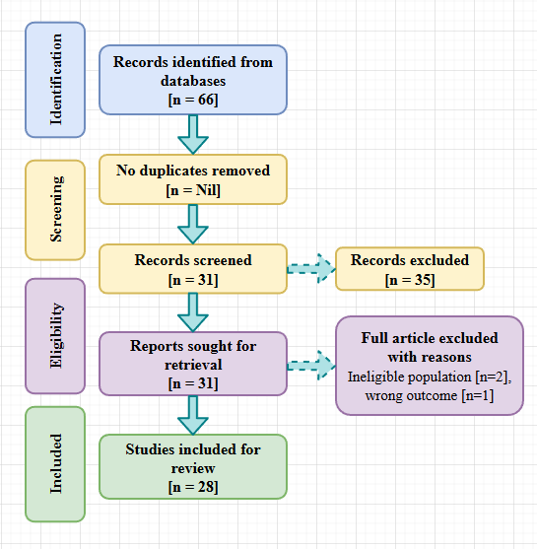
Figure a. PRISMA flow diagram depicting the selection process for studies included in the SLR.
Figure b and c show article trend and keyword frequency for during identification step and after PRISMA Procedure respectively. From figure b we can identify, though XAI was introduced since 2017, the application of XAI in agriculture were started in 2022.
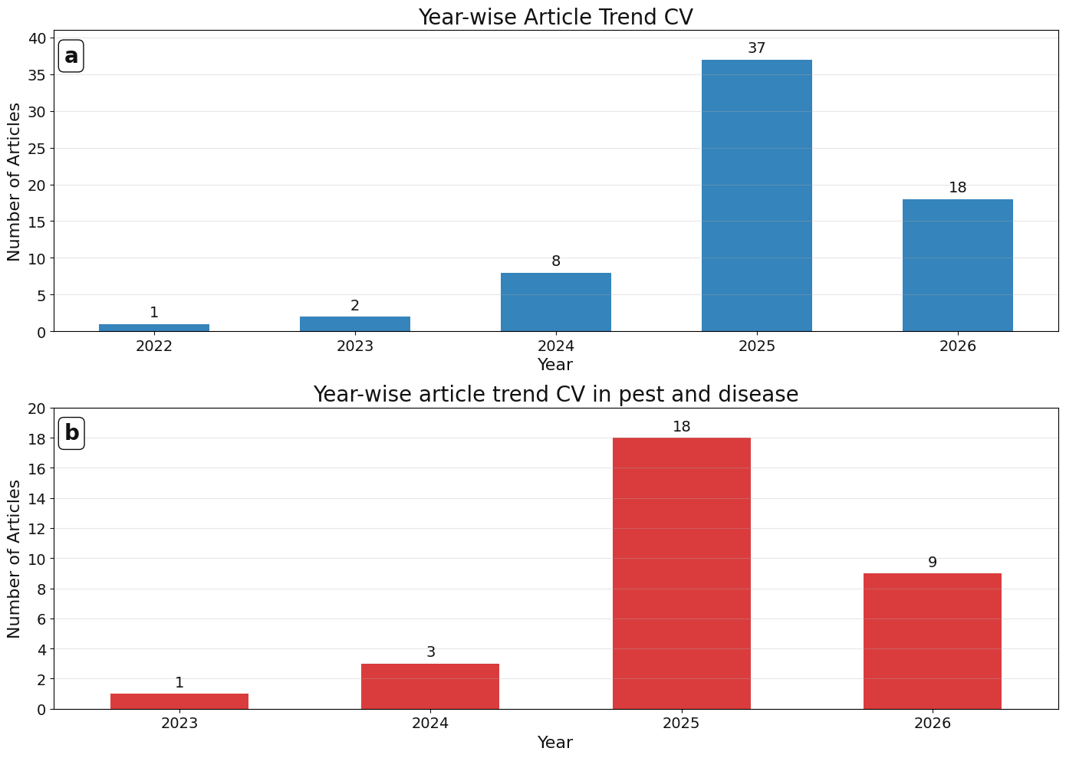
Figure b. year wise article trend in a.) identified articles and b.) selected articles.
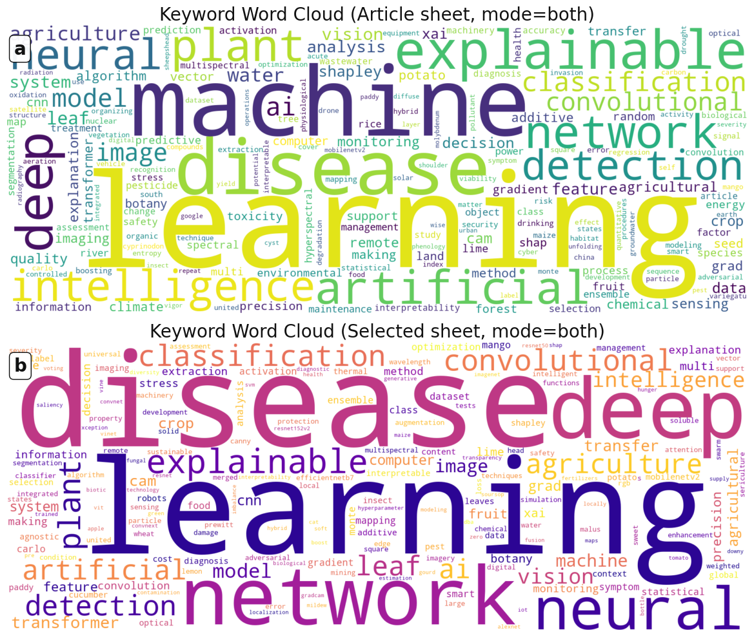
Figure c. Keyword cloud a.) in identified articles and b.) selected articles.
Table: 1 Search strategy for selected literature
Criterion | Inclusion Criteria | Exclusion Criteria
Domain | Agriculture, crops, plants, pests, weeds, and plant/crop diseases. | Medical, clinical, human health, radiology (MRI/CT), oncology, or neurology.
Task | Vision-based tasks: Object detection, instance segmentation, or specific architectures (e.g., YOLO, Faster R-CNN). | Non-vision tasks or general classification without a localization component.
AI Method | Explainable AI (XAI), explainable deep learning, or explainable machine learning. | "Black-box" models or standard DL/ML lacking interpretability/explanation components.
Output Type | Peer-reviewed journal articles (DOCTYPE, "ar"). | Conference papers, preprints, reviews, books, or short surveys.
Timeline | Published between 2018 and 2026. | Articles published in 2017 or earlier.
Subject Area | Agricultural, Computer Science, Environmental, Engineering, or Earth Sciences. | Areas unrelated to the technical or biological scope (e.g., Social Sciences, Arts).
Search String (Scopus) | ( TITLE ( "explainable AI" OR XAI OR "explainable deep learning" OR "explainable machine learning" ) ) AND ( TITLE-ABS-KEY ( "object detection" OR detect* OR "instance segmentation" OR YOLO OR "Faster R-CNN" ) ) AND ( TITLE-ABS-KEY ( agricultur* OR crop* OR plant* OR "plant disease" OR "crop disease" OR pest* OR weed* ) ) AND PUBYEAR > 2016 AND PUBYEAR < 2027 AND NOT ( TITLE-ABS-KEY ( human OR patient* OR medical OR medicine OR clinical OR MRI OR CT OR tumor* OR cancer* OR alzheimer* OR brain OR radiolog* OR pathology ) ) AND ( LIMIT-TO ( SUBJAREA,"AGRI" ) OR LIMIT-TO ( SUBJAREA,"COMP" ) OR LIMIT-TO ( SUBJAREA,"ENVI" ) OR LIMIT-TO ( SUBJAREA,"ENGI" ) OR LIMIT-TO ( SUBJAREA,"EART" ) ) AND ( LIMIT-TO ( DOCTYPE,"ar" ) )

